EDM profile for Sounds
Collection of use cases

The Task Force on EDM profile for Sounds aims at creating an EDM profile for describing sounds materials. The first step in the process is the collection of use cases. These cases will allow the Task Force to scope its activities and define clear requirements that will form the basis of the EDM profile for Sounds.

The current fields for the use case templates are:

1) Title of the use case(s)

Latvia’s historical sound recordings

2) Owner's case name and name of the represented institution

National Library of Latvia

Use case(s):
3) Provide a general description of your use case(s). You can also add to your use case(s) images, diagrams if needed.
A use should contain information on:
-what is the type of sound objects you provide Europeana (vinyle, recording, music sheet….)
-Are these objects composed of different elements? If yes, what is the type of the relationship between an object and its different components or between the components themselves?
-Do the objects have digital representations? And if yes, of what type (same recording in different formats, video, images…)?

Example from the report of the Task Force on Hierarchical Objects http://pro.europeana.eu/web/network/europeana-tech/-/wiki/Main/Taskforce+on+hierarchical+objects written by Rodolphe Bailly, Cité de la Musique.
At the Cité de la musique, a concert recording is documented as a hierarchy of records.
The first, top level record describes the "concert". It contains general information about the recording of the concert itself, such as title, date, location and the most important performers and composers. The other records describe the "constituents" of the concert, i.e. the musical works performed during the concert. Each of these constituent, situated at a lower level of the hierarchy, contains detailed information about the performed musical works (for instance the complete list of performers). If needed, each of the performed musical work record may also have constituent records, such as specific parts in a symphony.
This concert recording can be represented as follow:
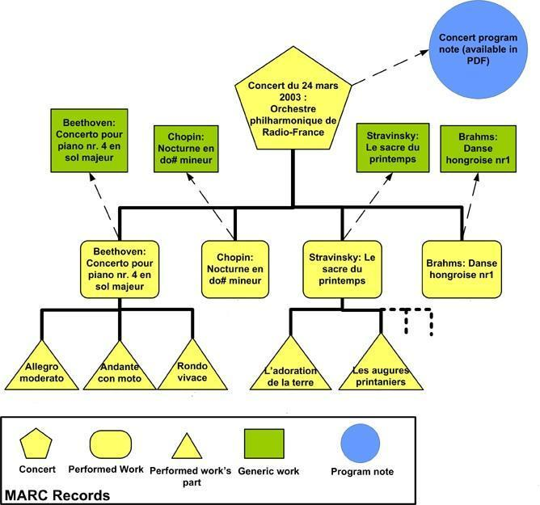

“Latvia’s historical sound recordings” is a collection of mostly digitized shellacs. We use plain structure of individual sound recordings, where each sound recording is a bundle of data consisting of: a.) EDM-based metadata; b.) link to one (or in rare cases several) audio file(s); c.) a shellac label image.

No hierarchical structure is used to present data. In case a recording is long enough to be spread across several shellacs, it still is considered to be a single object, simply, with several audio files attached.

Data sample illustrating the use case
4) Each use case should be illustrated by (a) data sample(s).
Upload your data sample(s) at https://drive.google.com/folderview?id=0B4N3jJ2PToabWU1scDVFZGVKVEU&usp=sharing and indicate the name of the file(s) in this questionnaire for reference.

The metadata files for this use case are uploaded to folder “NLL”. Each XML file contains all metadata for a single object.

Each XML contains an element <dom:uri> which points to representation of the sound recording in our digital object management system.

5) What metadata format is used in the samples(s)?

The metadata in the samples is EDM-based, but would require some final polishing/conversions, before it could be considered “pure EDM”.

6) Describe how you use this metadata format to support the described use case(s) (can include details on specific metadata elements, data quality aspects…)

The metadata we use is EDM-based (with some minor adjustments) and essentially contains both descriptive metadata for a single sound recording and technical metadata for each file associated with this recording.

Metadata also contain links to some important representations of this object:

- <dom:uri> - link to representation of sound recording object in NLL’s digital object management system.
- <dom:isShownAt> - same as <dom:uri> but with more browser-friendly URL format.
- <dom:thumbnail> - link to shellac label image.

Vocabularies
7) Are you using specific vocabularies(e.g. thesauri) to describe information such as subjects, genres in your metadata?
If not go to question 11.

Yes.

8) If yes, how are you using them? In which metadata fields?

We use person thesaurus for the fields “Creator” (<dom:creator>) and “Contributor” (<dom:contributor>); subject thesaurus for the field “Subject” (<dom:subject>). We also use vocabularies for the field “Contributor role” (<dom:contributorRole>) and “Publisher” (<dom:publisher>).

9) What is the language coverage of these thesauri/vocabularies?

All of the values from thesauri and vocabularies are in Latvian, although mapping to, for example, English values could also be created.

10) How are the thesauri/vocabularies represented (e.g. a database, an XML file, SKOS, etc.)? If possible provide an example of (a part) of the thesauri/vocabularies you use (e.g. a fragment of XML, etc.).
Copy and paste an example in the questionnaire or upload your vocabulary sample at https://drive.google.com/folderview?id=0B4N3jJ2PToabWU1scDVFZGVKVEU&usp=sharing and indicate the name of the file(s).

The thesauri we use are primarily stored in our bibliographic catalogue system (ExLibris ALEPH), but we can export them in XML if necessary.

Enrichment
11) If you are not using thesauri/vocabularies, would you like to see your metadata enriched with references to thesauri/vocabularies?

N/A

12) Which metadata fields would you like to see enriched?

N/A

